

**LAB FILE**

**Web Programming with Python and JavaScript Lab**

**(SEC 035)**

**SUBMITTED BY:**

**ADEELA AZEEZ**

**SUBMIITED TO:**

**DR. TANVI CHAWLA**

**ROLL NUMBER: 2301010282**

**COURSE: BTECH CSE CORE**

**SECTION: E**

**School of Engineering & Technology**

**K. R. MANGALAM UNIVERSITY**

**Sohna, Haryana 122103, India**

**EXPERIMENT 10**

**Basic Python Programs**

***Experiment 10.1: WAP to print Area Of Circle, Square, Rectangle***

**Code:**

def area_circle():

    r=float(input("Enter radius of the circel: "))

    a=3.14*r*r

    print("The area of circle is: ", a)

def area_rectangle():

    l=int(input("Enter length of rectangle: "))

    b=int(input("Enter breadth of rectangle: "))

    a=l*b

    print("The area of rectangle: ", a)

def area_square():

    s= int(input("Enter side of the square: "))

    a=s*s

    print("The area of square is: ", a)

choice =input("Choose calulate area for: circle/rectangle/square:  ").lower()

if choice=="circle":

    area_circle()

elif choice=="rectangle":

     area_rectangle()

elif choice=="square":

    area_square()

else:

    print("Invalid choice")

**Output:**

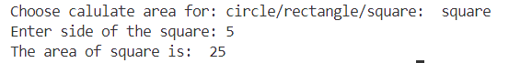

***Experiment 10.2: WAP in python to create a calculator***

**Code:**

def calculator():

    num1=float(input("Enter first number: "))

    num2=float(input("Enter second number: "))

    operator=input("Enter operator: ")

    if operator=='+':

        print("Result: ", num1+num2)

    elif operator=='-':

        print("Result: ", num1-num2)

    elif operator=='*':

        print("Result: ", num1*num2)

    elif operator=='/':

        if num2!=0:

            print("Result: ", num1/num2)

        else:

            print("Cannot divide by zero")

    else:

        print("Invalid operator")

calculator()

**Output:**

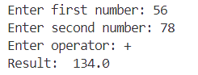

***Experiment 10.3: WAP to print Fibonacci Series***

**Code:**

def fibonacci(n):

    if n <= 0:

        return []

    elif n == 1:

        return [0]

    elif n == 2:

        return [0, 1]

    series = fibonacci(n - 1)

    series.append(series[-1] + series[-2])

    return series

num = int(input("Enter the number of terms: "))

print("Fibonacci Series:", fibonacci(num))

**Output:**



***Experiment 10.4: WAP to check if input string is palindrome or not***

**Code:**

def is_palindrome(s):

    reversed_s = s[::-1]

    print(f"Reversed String: {reversed_s}")

    if s == reversed_s:

        print("The string is a palindrome.")

    else:

        print("The string is not a palindrome.")

string = input("Enter a string: ").lower()

is_palindrome(string)

**Output:**

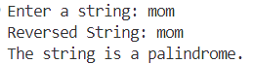

***Experiment 10.5: WAP to print following patterns***

1. ***\****

***\* \****

***\* * \****

***\* * * \****

**Code:**

n=4

for i in range(1, n + 1):

    for j in range(1, i + 1):

        print('*', end=" ")

    print()

**Output:**

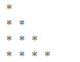

1. ***1***

***1 2***

***1 2 3***

***1 2 3 4***

**Code:**

n = 4

for i in range(1, n + 1):

    for j in range(1, i + 1):

        print(j, end=" ")

    print()

**Output:**

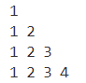

***Experiment 10.6: WAP to create a To-Do List***

**Code:**

tasks=[]

def add_task(task):

    tasks.append(task)

def remove_task(task):

    if task in tasks:

        tasks.remove(task)

def show_tasks():

    print("To-DO-LIST")

    for i, task in enumerate(tasks, start=1):

        print(f"{i}.{task}")

while True:

    choice =input("Choose: add/remove/show/quit: ").lower()

    if choice=="add":

        task=input("Enter a task: ")

        add_task(task)

    elif choice=="remove":

         task = input("Enter task to remove: ")

         remove_task(task)

    elif choice=="show":

        show_tasks()

    elif choice=="quit":

        break

    else:

        print("Invalid choice")

**Output:**

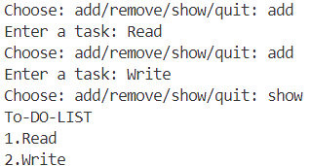

***Experiment 10.7: Conditional Statements***

**Code:**

num = int(input("Enter a number: "))

if num > 0:

    print("Positive number")

elif num < 0:

    print("Negative number")

else:

    print("Zero")

**Output:**



***Experiment 10.8: Loops***

**For Loop**

**Code:**

for i in range(5):

    print(i)

**Output:**

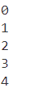

**While Loop**

**Code:**

count = 0

while count < 5:

    print(count)

    count += 1

**Output:**



***Experiment 10.9: WAP to print characters of a string***

**Code:**

s=input("Enter a string: ")

for i in range(len(s)):

    print (s[i])

**Output:**

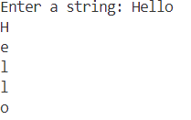

***Experiment 10.10: WAP to print sum of digits of a number entered by the user***

**Code:**

n=int(input("Enter a number: "))

sum=0

while(n>0):

    d=n%10

    sum+=d

    n=n//10

print("The sum of number is: ", sum)

**Output:**



***Experiment 10.11: WAP to convert temperature in Fahrenheit to Celsius and Celsius to Fahrenheit***

**Code:**

tempF=int(input("Enter temperature in Fahrenheit: "))

tempC=(5/9)*(tempF-32)

print("The temperature in Celsius is: ", tempC)

tempC2=int(input("Enter temperature in Celsius: "))

tempF2=(9/5)*(tempC2)+32

print("The temperature in Fahrenheit is: ", tempF2)

**Output:**

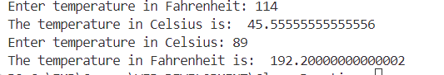

***Experiment 10.12: WAP to check if input string is palindrome or not***

**Code:**

def is_palindrome(s):

    reversed_s = s[::-1]

    print(f"Reversed String: {reversed_s}")

    if s == reversed_s:

        print("The string is a palindrome.")

    else:

        print("The string is not a palindrome.")

string = input("Enter a string: ").lower()

is_palindrome(string)

**Output:**



***Experiment 10.13: WAP to count characters of a string***

**Code:**

for i in range(len(s)):

    if(s[i].isalpha()):

        sum+=1

print("The number of characters in given string is: ", sum)

**Output:**

